**Lab1 Docker Deployment**

**薛劭杰 1930026143**

**Task 1: Create a virtual network via docker**

**Firstly, Create the virtual network, and the containers can access each other later.**

**# docker network create + “your network name”**



**And we can see the information and status of all networks.**

**# docker network ls**

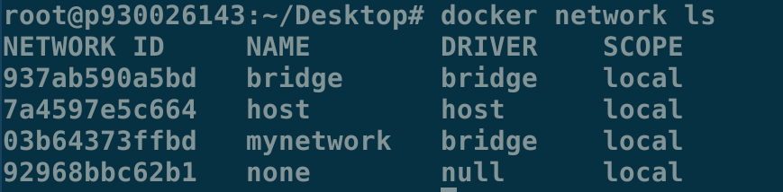

**Check the network just created and you can find the gateway and other network IP address information.**

**# docker network inspect “your network name”**

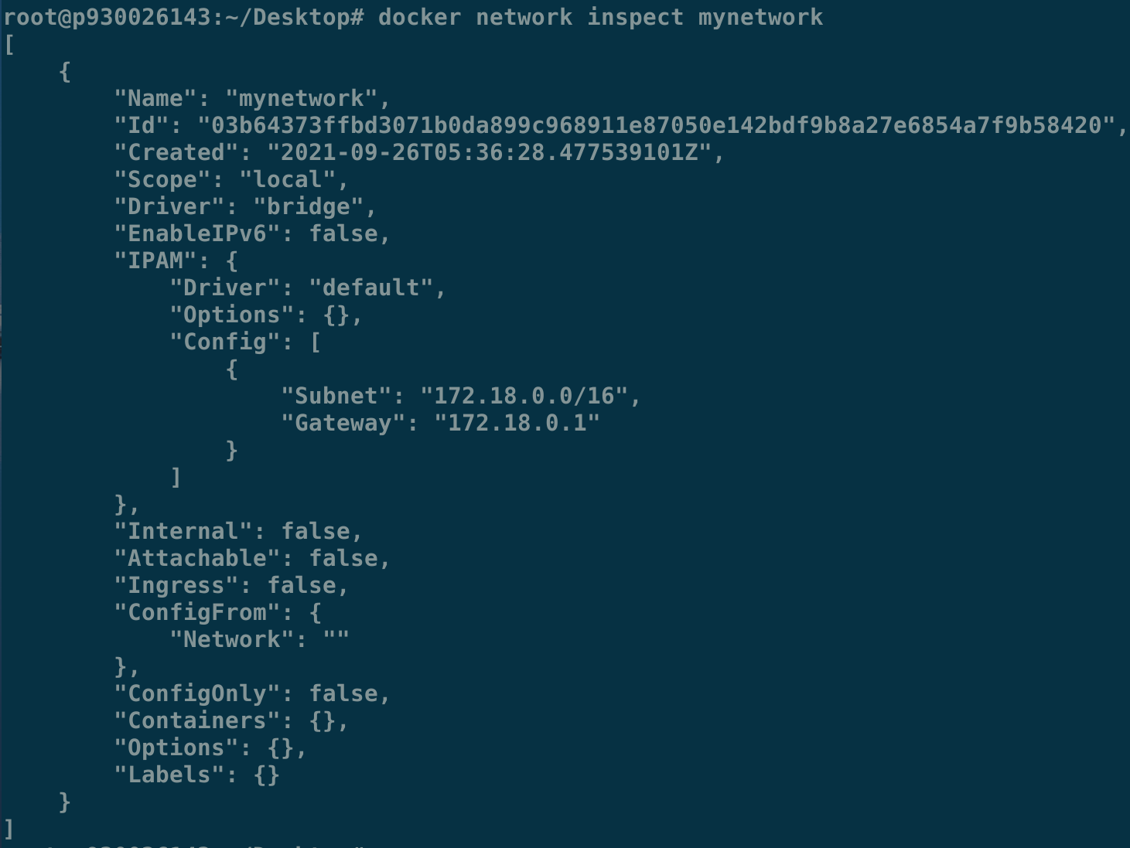

**Task 2: start a MySQL database by pulling the MySQL container from the docker server**

**Join the virtual network (mynetwork), map the port 3306, set the root password, add a user (microblog) and you can also use the other username you want, and password (111111) you can also specify by yourself, and you specify MySQL version (5.7). (It can pull the image automatically)**

**# docker run –name=mysql –network=mynetwork -p 3306:3306 -d -e \ MYSQL_RANDOM_ROOT_PASSWORD=yes -e \**

**MYSQL_DATABASE=microblog –e MYSQL_USER=microblog –e \**

**MYSQL_PASSWORD=111111 mysql/mysql-server:5.7**

**(Using the “\” in the end of line to line feed)**

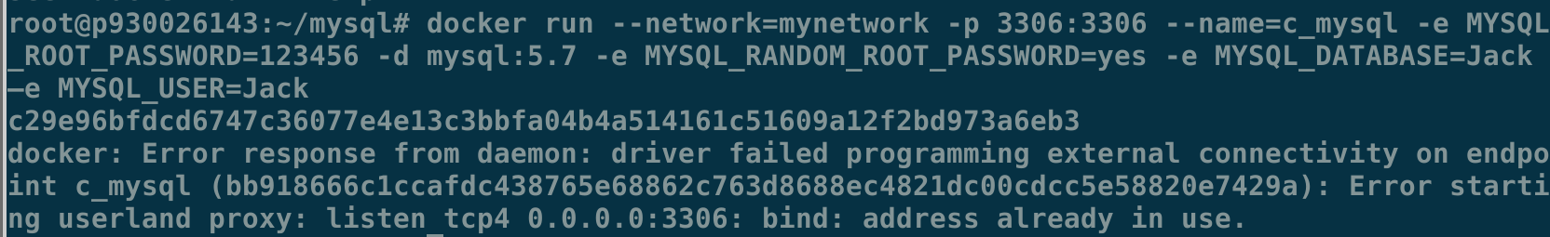

**Before that, you can pull the images mysql/mysql-server:5.7.**

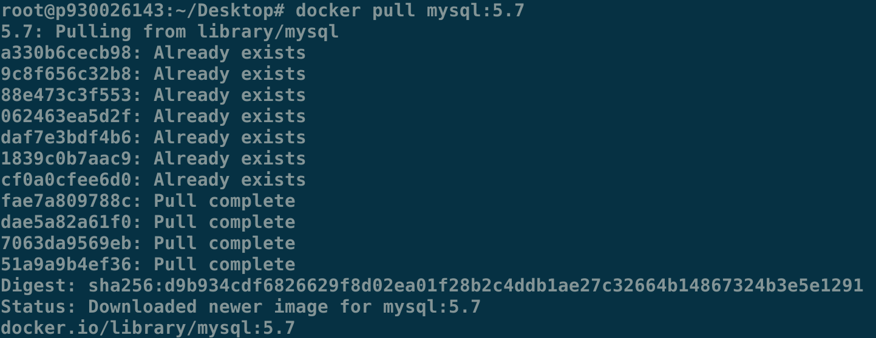

**If the code has some bugs or errors, it may already have created the image with some errors. You can use the code below to remove.**





**Task 3: Create a web server container and run it**

**Initially, download the lab1_deployment.zip from Ispace to the location you want, unzip the package.**

**Then you can get your message like the version number and the location of the document and directory.**

**# uname -a**

**# pwd**



**You have to make adjustments for two files in this directory. One is Dockerfile.**

**Information enclosed in red box should be changes. Special attention is that you must add /home before entering the path obtained by pwd, which is as your work directory.**

**# vim Dockerfile**

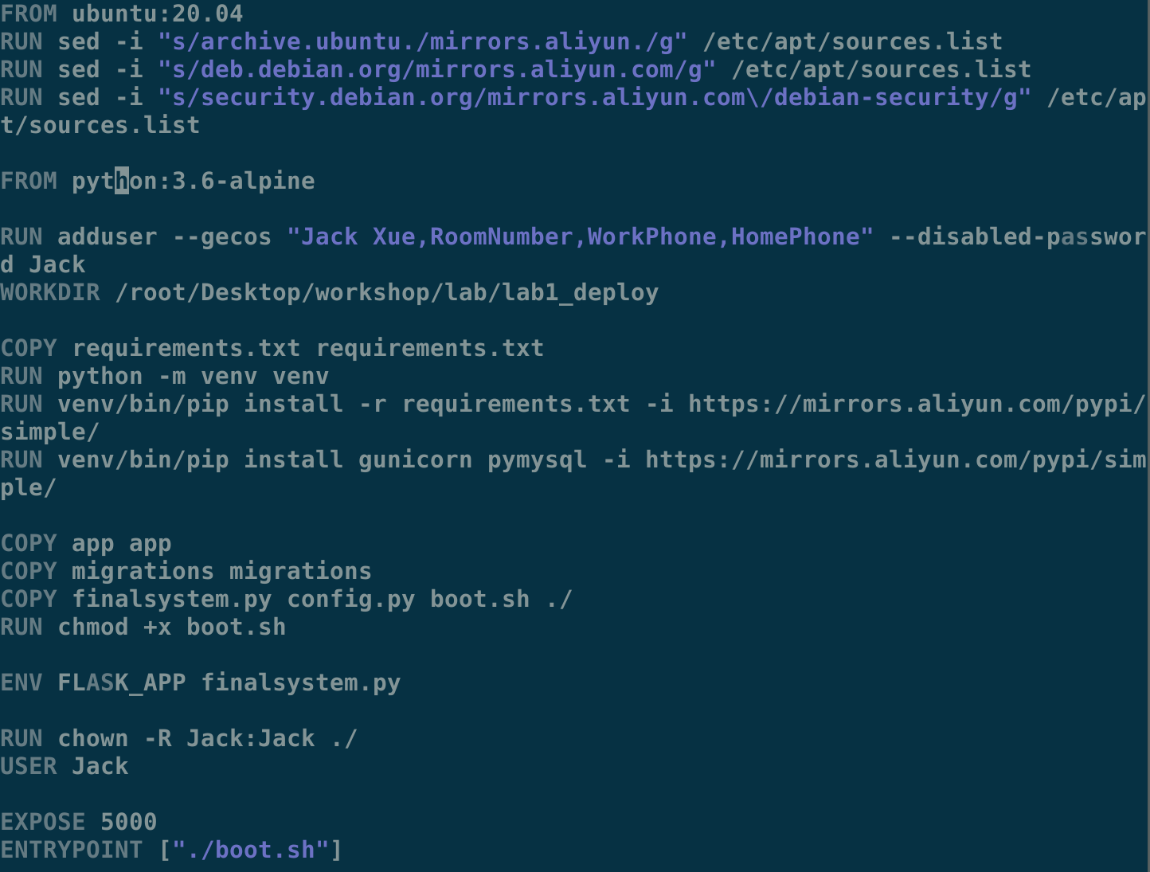

**We can check the IPv4 address of the virtual network by the below command.**

**# docker network inspect “your network name”**

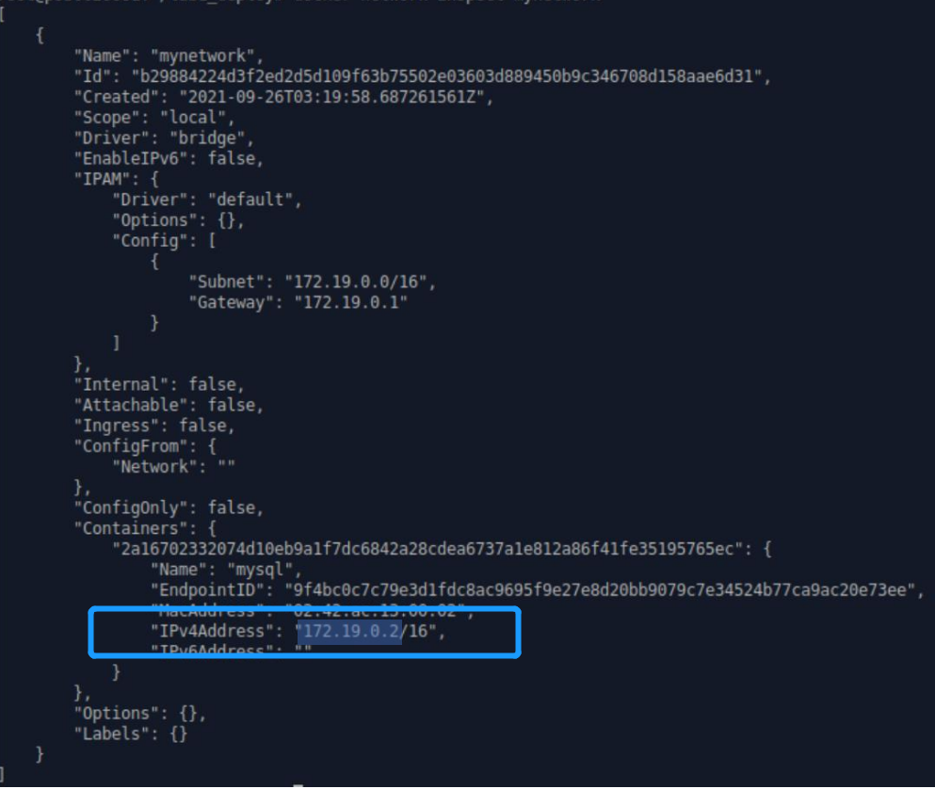

**The red box content may need to be changed. Since the username and password may be the same as we suggested, you may only need to change the IPv4 address (here my case is 172.19.0.2).**

**# vim config.py**

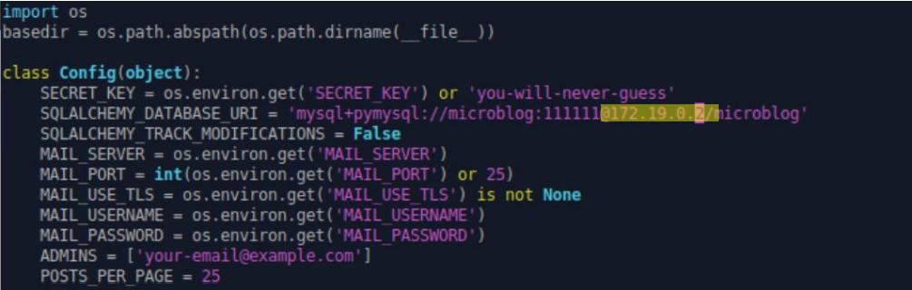

**Now, you have the required docker configuration files, as well as the web service files. Next you need to build the container for the web server. Type the following command:**

**# docker build -t finalsystem:latest .**

**Pay attention to the “.” dot in the end of the command**

**Suppose that your current folder is lab5_deploy. You will see similar messages on your terminal as follows. You should make sure that all of the steps were finished.**

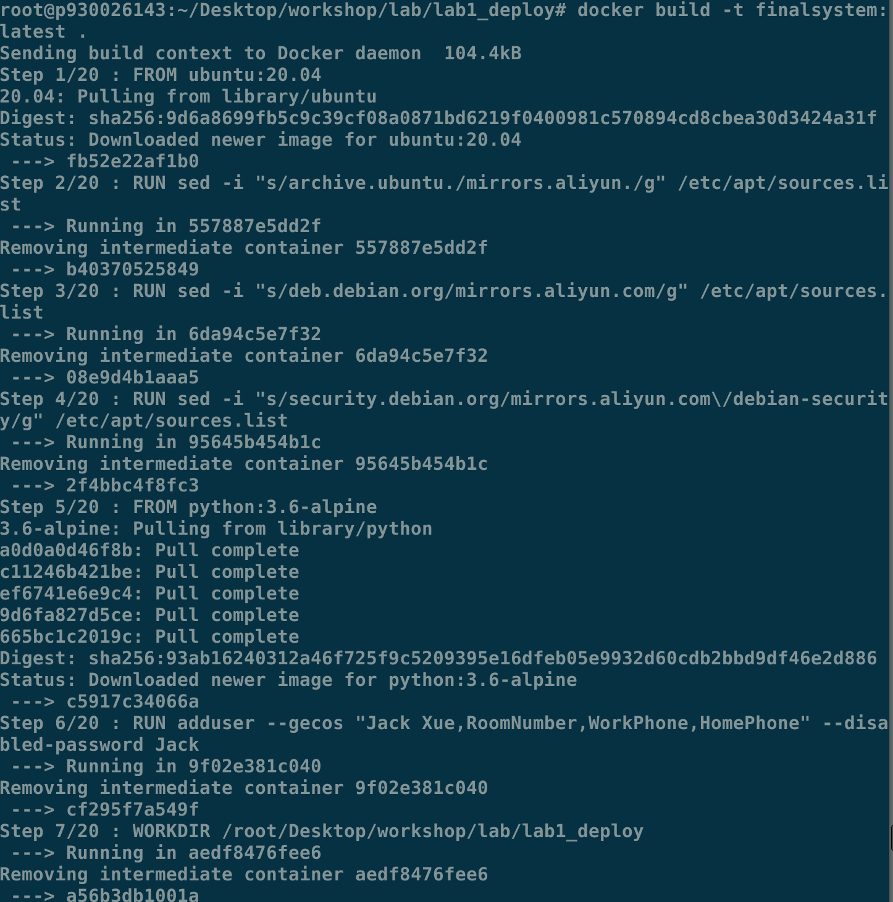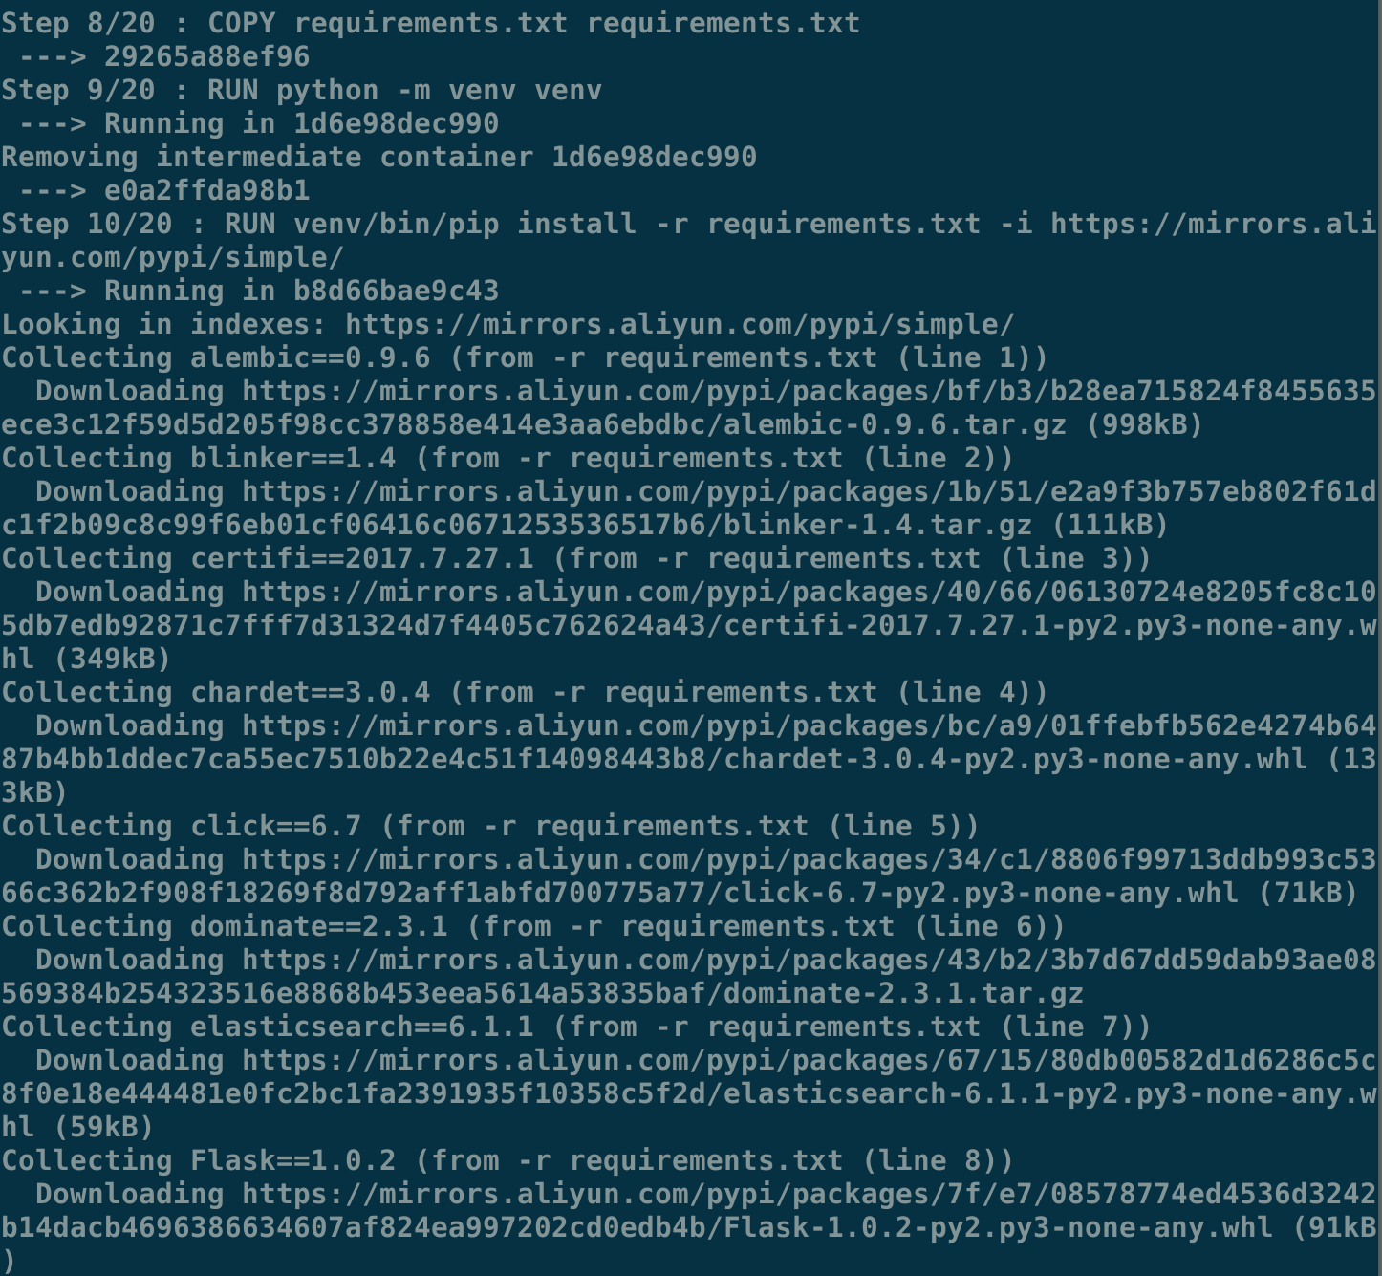

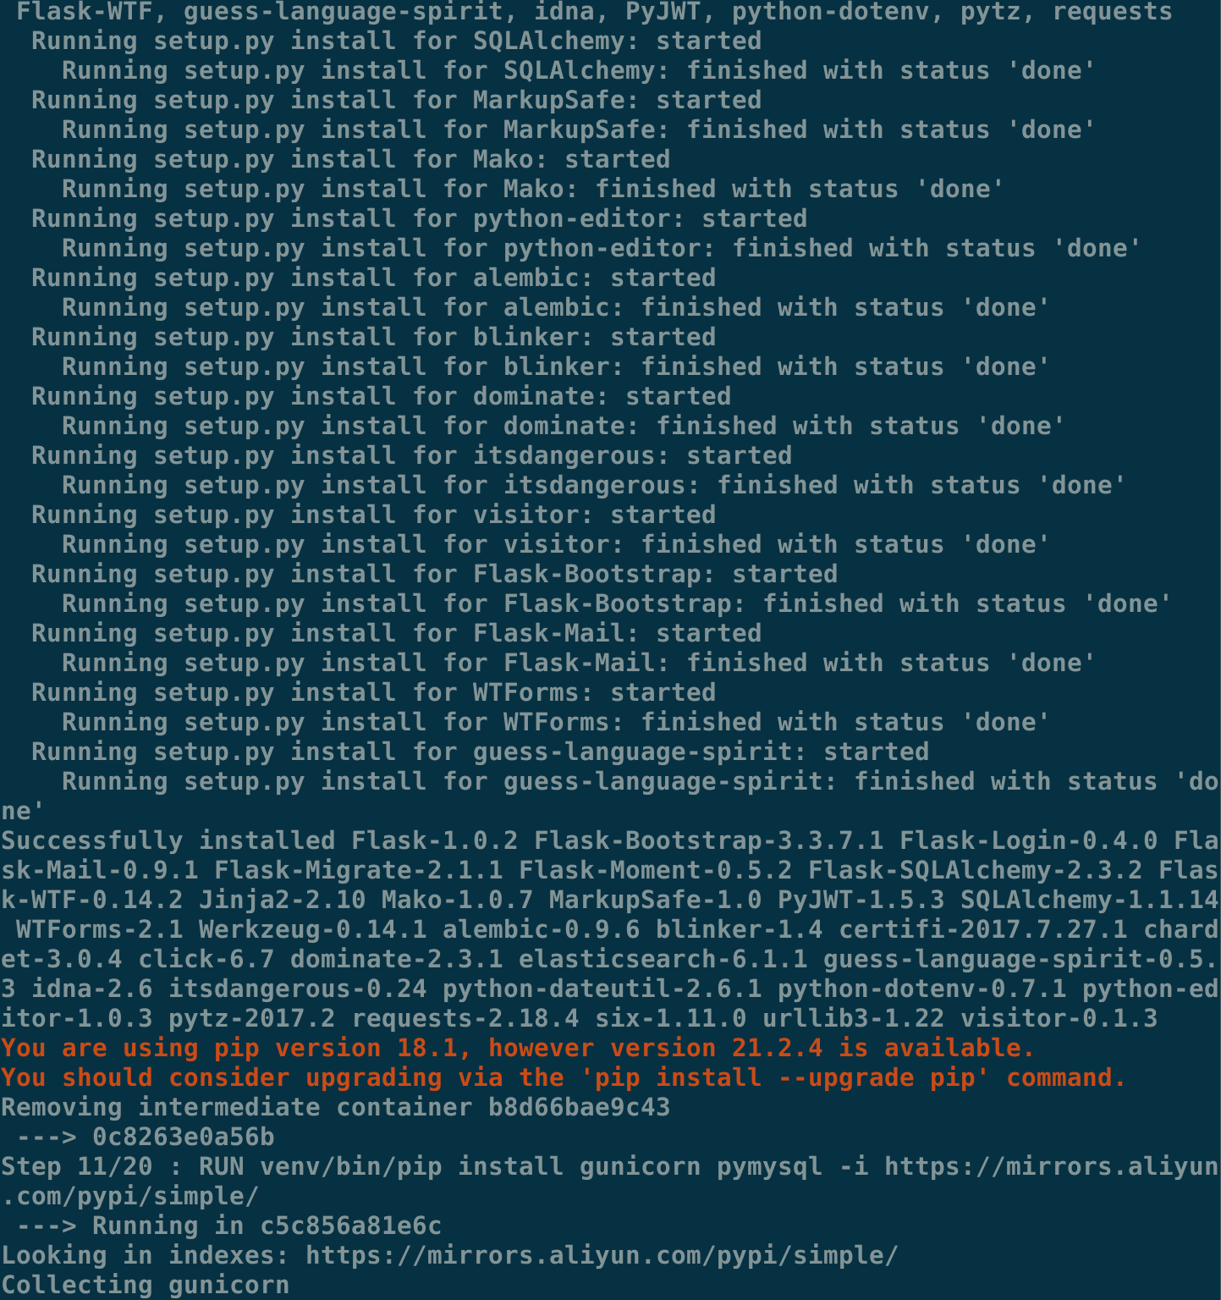

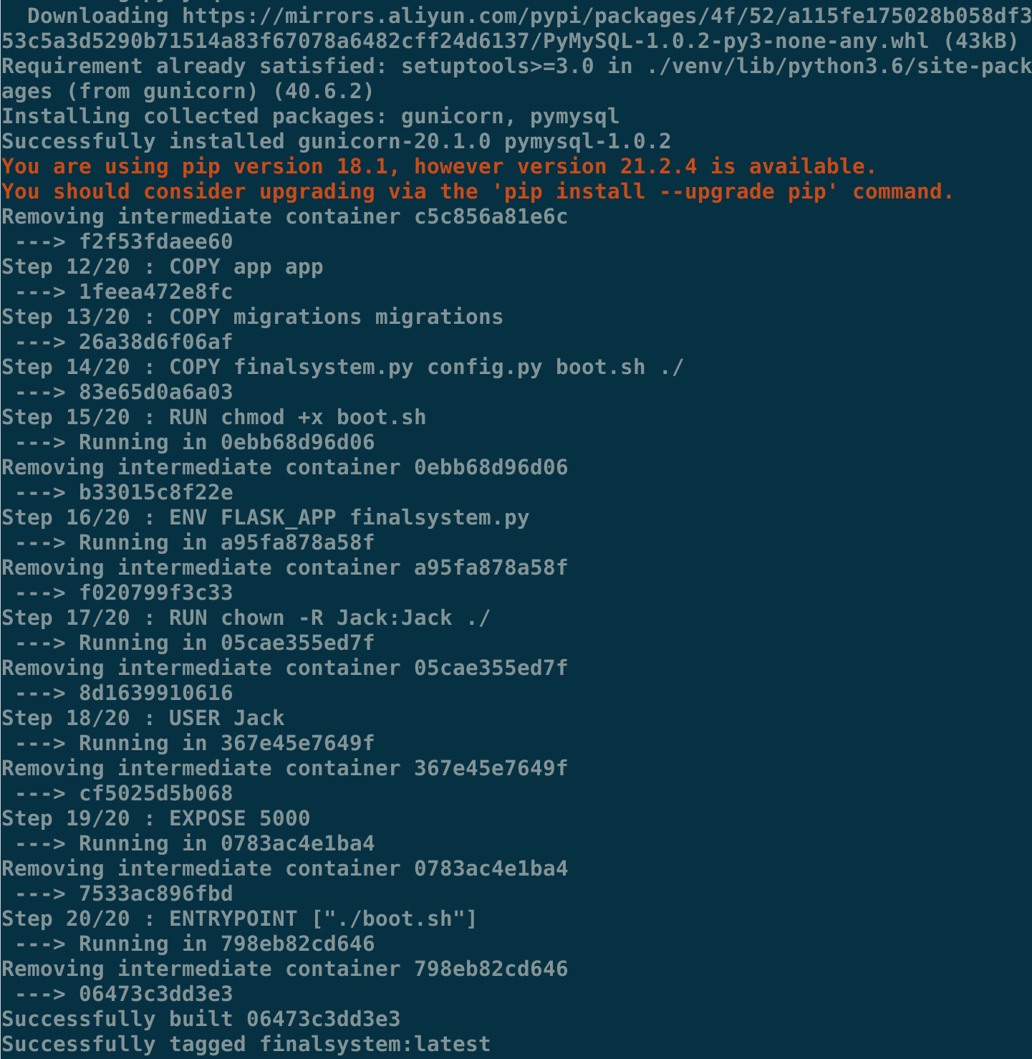

**Then after that, you can check the status by the command and make sure they are active. # docker ps or # docker ps -a**

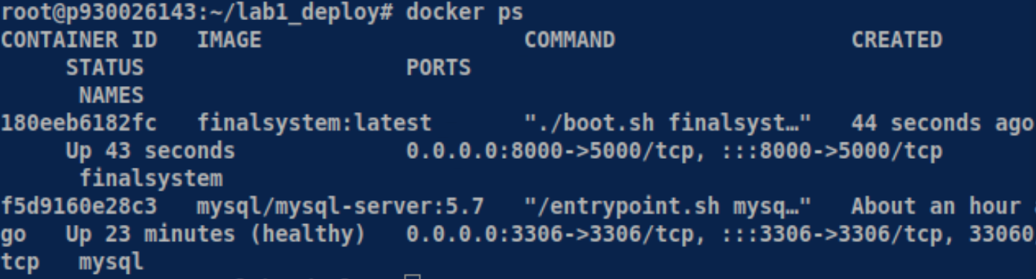

**Task 4: open a webpage on Firefox browser to check two servers are running correctly.**

**Using the web browser to enter the http://localhost:8000/login and then following page will be display. (Note: http, not https）**

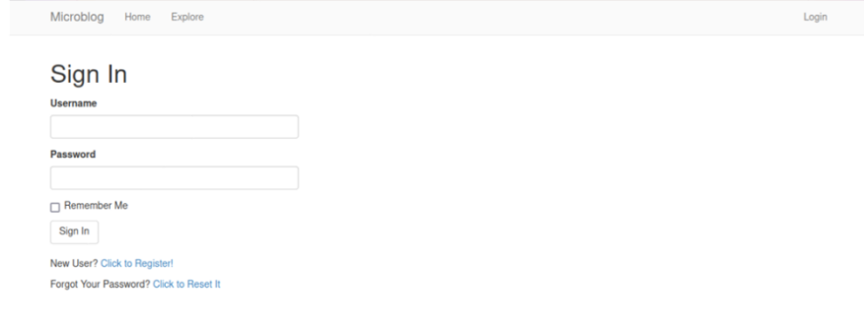

**Sign in if you already have an account and password or register as a new user. The step of register, click the following button for register a new account.**

If you login, it displays the web page to allow you to submit new posts in the following web page:

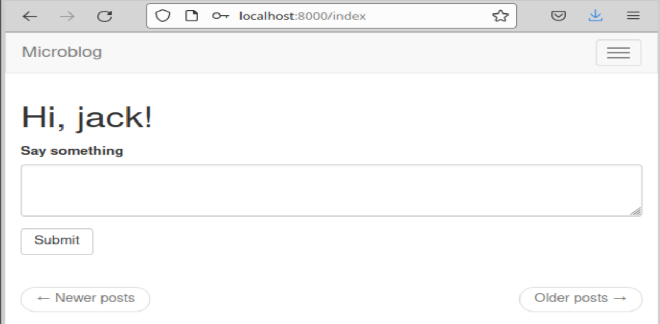

**Task 5: Install mysql-workbench on Ubuntu 20.04**

**You can download:**

**mysql-workbench-community_8.0.26-1ubuntu20.04_amd64.deb from https://dev.mysql.com/downloads/workbench/ and install it. You should select the 20.04 which is identical to your version number**

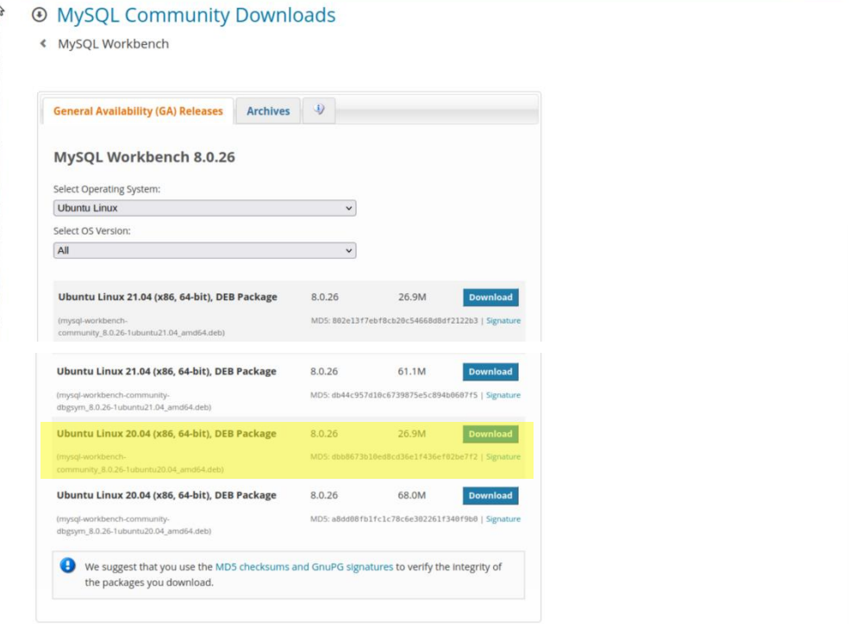

**Enter to the directory where the downloaded file is, suppose it is in your Downloads (Note: If you download in other place or download other version, you have to modify the corresponding command)**

**# cd ~/Downloads (you can select any location you want)**

**Then install the deb document by the command**

**# sudo apt install ./mysql—workbench—community_8.0.26—1ubuntu 20.04_**

**amd64 .deb**

**! Pay attention to the “./”after the install, it means that at this current path.**

**After entering the MySQL workbench, selecting database on the menu bar above and you can click the “Connect to Database”.**

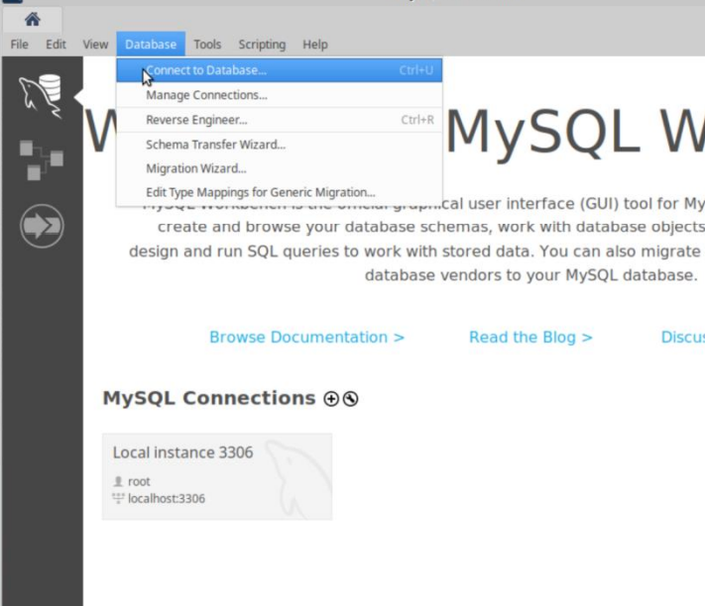

**See the connection database settings dialog box, enter the user name is microblog, the password for the edit box is 111111. (The name and password you set in the command line to create the mysql/mysql-service image) and then click OK.**

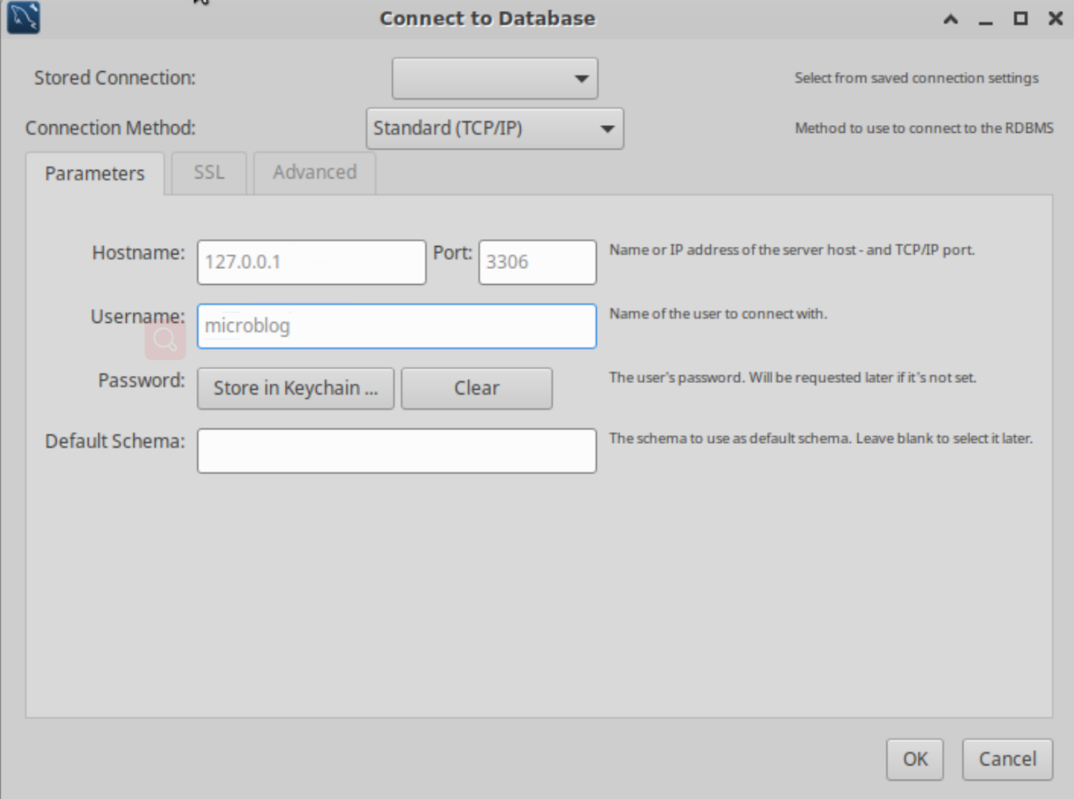

**If you can see the following interface, it means you have successfully connected to the database**

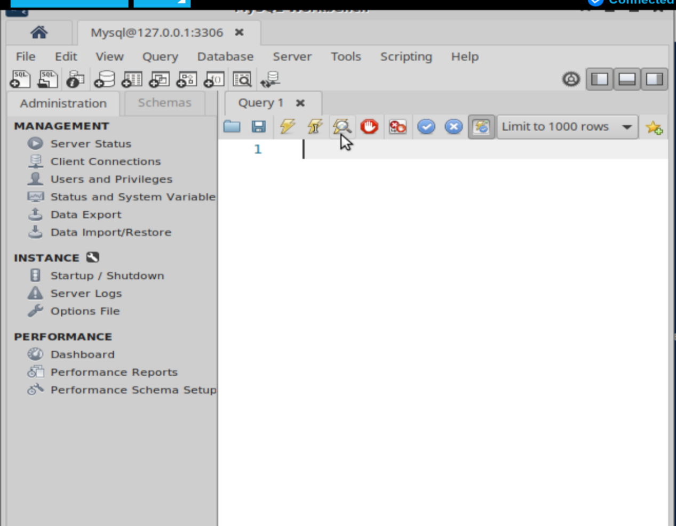

**You can post some messages in the** [**http://localhost:8000/index**](http://localhost:8000/index) **that you login in just now.**

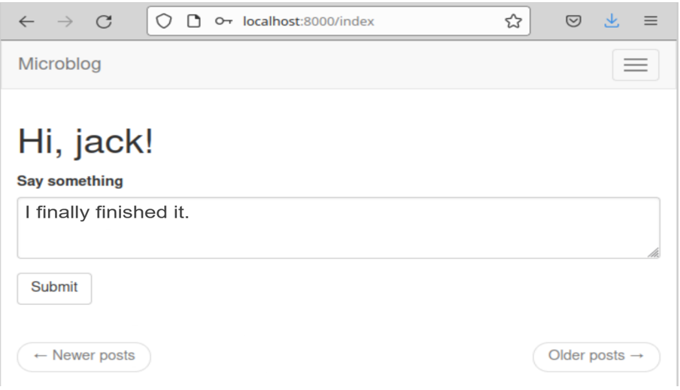

**After that, you can input some MySQL statement to search the record.**

**Like below, you can see the message you posted and the information about it.**

**(SELECT *FROM microblog.post)**

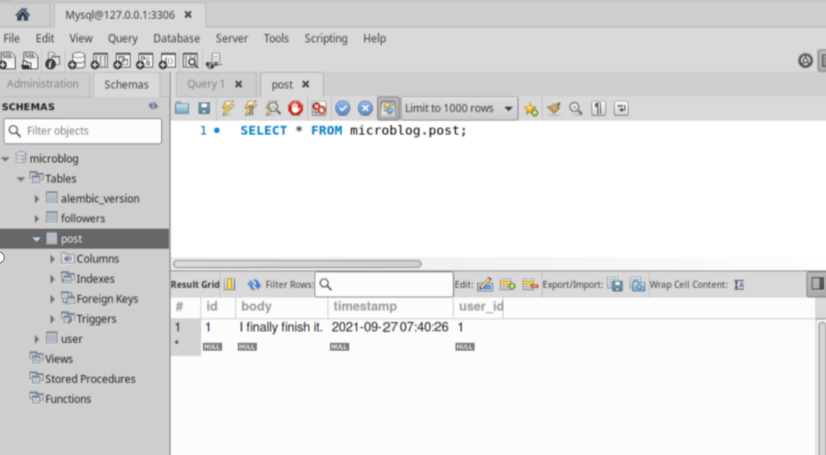

**If you do not want to use the MySQL workbench, you can also use the MySQL ubuntu system comes with and check the database.　# mysql -u root -p**

